Gift Aid Declaration
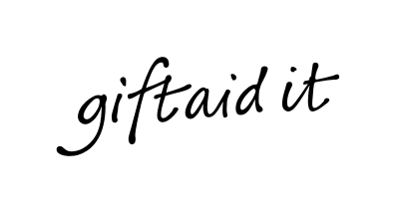
Add 25% more to your donation at no cost to you. A Gift Aid declaration allows Music as Therapy to claim tax back on eligible donations. It means that for every £1 you donate to Music as Therapy we can claim back 25p, at no extra cost to you.

Donor’s declaration:
I am a UK taxpayer and understand that if I pay less Income Tax and/or Capital Gains Tax in the current tax year than the amount of Gift Aid claimed on all my donations it is my responsibility to pay any difference.

Please treat… (Please tick the appropriate box)
the enclosed gift of £ _____________________ as a Gift Aid donation; OR
all gifts of money that I make today and in the future as Gift Aid donations; OR
all gifts of money that I have made in the past four years and all future gifts of money that I make from the date of this declaration as Gift Aid donations.

Gift Aid is reclaimed by the charity from the tax you pay for the current tax year. Your address is needed to identify you as a current UK taxpayer.

Donor’s details (please complete in BLOCK CAPITALS):

Title Mr / Mrs / Miss / Ms / Other_______ Please delete as applicable

Forenames (in full) Su Surname

Home address

Postcode

Signature Date

Please notify us if you:
- want to cancel this declaration
- change your name or home address
- no longer pay sufficient tax on your income and/or capital gains

If you pay Income Tax at the higher or additional rate and want to receive the additional tax relief due to you, you must include all your Gift Aid donations on your Self-Assessment tax return or ask HM Revenue and Customs to adjust your tax code.

